**DEPARTMENT OF PHYSICAL PLANNING**

**AN INDUSTRIAL TRAINING REPORT CARRIED OUT WITH ENTEBBE MUNICIPAL COUNCIL LIMITED FROM JUNE TO AUGUST 2025**

**BY**

**NALUGWA JOAN**

**UBV007/2024/D/D/A/1296**

**SUPERVISOR: MR TULIRINYA JOHN**

**REPORT SUBMITTTED IN PARTIAL FULFILLEMENT OF THE REQUIREMENTS FOR THE AWARD OF INSTITUTE OF SURVEY AND LAND MANAGEMENT**

**DECLARATION**

I hereby declare to the best of my knowledge that I am the author of this report. I have citied the sources from which I obtained the data I used and this work has never been submitted to any institution for the award of diploma in physical planning.

I also certify that this report was prepared by me specifically for the partial fulfillment of the requirement for the award of a diploma in Physical planning of institute of Survey and Land Management.

Signature ………………………………………….

Date ……………………………………………….

Registration Number ………………………………

**DEDICATION**

First and foremost, I would like to dedicate this report to the almighty GOD who gave me wisdom, strength and motivation. I thank Him for provision throughout my entire academic journey.

Secondly, I appreciate my parents, Mr. & Mrs. David and Agnes Ssenyondwa, Mr. Francis Dulaney, my friends Kato James and Naloda Gerald who have supported me financially throughout my internship.

I would also like to appreciate my colleagues Kemisa Sharitah, Kwagala Mercy, Mulungi Praise, Osipo Peter and Epilu Peter whom I have worked with at the Municipal.

Lastly, I would like to dedicate this report to all the members and Staff of Entebbe Municipal Council, the Physical Planning Unit in particular and Mr. Kabanda Simon in a special way, who offered guidance to me throughout my internship period.

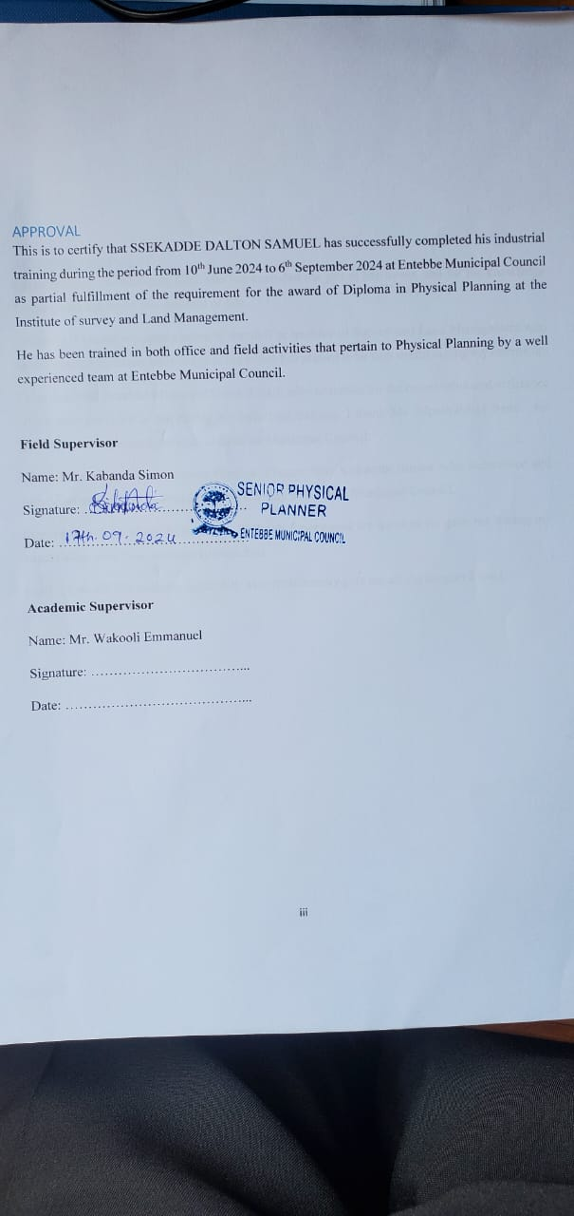

**APPROVAL**

This is to certify that NALUGWA JOAN has successfully completed his industrial training during the period from 16th June 2025 to 15th August 2025 at Mbale District Local District as partial fulfillment of the requirement for the award of National Diploma in Physical Planning at the Institute of survey and Land Management.

She has been trained in both office and field activities that pertain to Physical Planning by a well experienced team at Mbale District Local Government.

**Field Supervisor**

Name: Mr. Sula Abasi

Signature: ………………………………

Date: ……………………………………

**Academic Supervisor**

Name: Mr. Tulirinya John

Signature: ……………………………...

Date: …………………………………...

**ACKNOWLEGDEMENT**

I greatly thank the Almighty God who has extended the gift of life to me, and for the knowledge he has provided me to this moment of life.

Secondly, I extend my appreciation to the staff at Institute of Survey and Land Management who have imparted immense knowledge to me which has proved to be very useful during my internship.

I also thank the Entebbe Municipal Council staff, administrators for the cooperation and assistance which they provided to me during my industrial training. I thank Ms. Mpamulungi Irene for giving me an opportunity to train at Entebbe Municipal Council.

**Special** thank goes to the Senior Physical Planner **Mr. Kabanda Simon** who supervised and instructed me and my colleagues during our stay at Entebbe Municipal Council.

Sincere thanks go to my lecturer Mr. **Wakooli Emmanuel** for the time he gave me during my supervision, may God continue to bless him.

Lastly, I would like to thank my family who continuously give me all the support I need.

**LIST OF ACRONYMS**

MDLC Mbale District Local Government

GPS Global Positioning System

CBD Central Business Centre

NPDP National Physical Development Plan

PPD Physical Planning Department

PPC Physical Planning Committee

ISLM Institute of Survey and Land Management

GIS Geographic Information System

PPA Physical Planning Act

ICT Information and Communication Technology

MZOs Ministry Zonal Offices

**LIST OF FIGURES**

Figure 1 A map of Entebbe Municipality 10

Figure 2 The main building of Entebbe Municipal Council 11

Figure 3 Showing the display of EMC Physical Development Plan 2020-2024 16

Figure 4 Showing the display of EMC Physical Development Plan 16

Figure 5 Showing a house which was constructed in a swamp 17

Figure 6 Showing poor solid waste management in Nakiwogo, EMC 19

Figure 7 Showing poor solid waste management 19

Figure 8 showing the encroachments on a wetland by settlements. 21

Figure 9 Public sensitization about the National building codes by the National Building Review Board (NBRB) 22

Figure 10 Showing public sensitization by the NBRB incorporation with EMC. 23

Figure 11 Showing the banner we used at the sensitization 24

Figure 12 Showing inspection of a plot which needed conversion from customary to freehold 28

Figure 13 Showing the inspection of a development building 29

Figure 14 A workshop organized to sensitize the leaders of EMC about climate change in Entebbe 30

Figure 15 Sensitization about physical planning 30

Figure 16 A sample of a PPA 2 form 32

Figure 17 Showing plans recording 32

Figure 18 Showing entering of records 33

Figure 19 Showing inspection of a commercial building 35

Figure 20 Showing site inspection and filling the requirements on the form 36

Figure 21 Showing inspection of a residential building 36

Figure 22 Practicing AutoCAD in the office 39

*Figure 1: showing the obstruction by already existing signpost.* 44

Figure 1: showing a setback 49

Figure 2: showing the ample space for parking and green grass 50

Figure 3: Showing the accessible road of the building 51

Figure 4: Showing the Building Height and Floor Area Ratio 52

**EXECUTIVE SUMMARY**

This report provides a general overview of Entebbe Municipal Council organization and activities of its operations. The municipality’s physical planning unit works to implement the National Physical Planning Standards and guidelines with an ambition to regulate development within Entebbe Municipality.

The report portrays the knowledge and skills acquired during the placement period. The report dwells on both practical and office experiences gained while working at Entebbe Municipal Council. It presents the relevance of skills gained, strength and shortcomings encountered during work related learning, opportunities encountered and recommendations for improvement on both employer and the Institute of Survey and Land Management.

Table of Contents

CHAPTER ONE 1

**1.0 INTRODUCTION** 1

**1.1DEFINITION** 1

**1.2 OBJECTIVES OF INDUSTRIAL TRAINING** 1

**1.2.1General objectives** 1

**1.2.2 Specific objectives** 1

CHAPTER TWO 2

**2.0 THE ORGANIZATION ENTEBBE MUNICIPALITY** 2

**2.1 LOCATION OF THE MUNICIPALITY** 2

**2.2 Historical background** 3

**2.3 Mission and Vision.** 3

**2.3.1 Mission.** 3

**2.3.2 Vision.** 4

**2.4 Objectives of the organization.** 4

CHAPTER THREE 5

**3.0 STRUCTURE OF ENTEBBE MUNICIPAL COUNCIL.** 5

**3.1 Planning hierarchy Entebbe Town Council.** 5

**3.2 Activities of Entebbe Municipal Council in general** 7

**3.3 Challenges faced by Entebbe Municipal Council.** 9

**3.4 possible solutions in order to overcome the challenges of EMC** 13

CHAPTER FOUR 16

**4.0 THE PHYSICAL PLANNING DEPARTMENT** 16

**4.1 Legal Frame Work Guiding Physical Planning Activities at EMC.** 16

**4.1 Activities carried out by the Entebbe Municipal Planning Department** 17

**4.1.2 Field activities** 18

**4.3 Tasks assigned to the trainee.** 25

**4.4 NEW KNOWLEDGE AND SKILLS ACQUIRED FROM THE TRAINING.** 28

**4.5 CHALLENGES EXPERIENCED AND HOW THEY WERE HANDLED.** 30

**4.6 MAJOR BENEFITS ATTAINED FROM THE TRAINING.** 30

CHARPTER FIVE 31

**5.0 CONCLUSION AND RECOMMENDATIONS** 31

**5.1 CONCLUSION** 31

**5.2 RECOMMENDATIONS** 31

**5.2.1 To the organization** 31

**5.2.2 To the institute** 32

REFERENCES 43

5.3 APPENDICES 44

**APPENDIX A: INTERNISHIP LOGBOOK.** 44

**APPENDIX B: REQUIREMENTS FOR DEVELOPMENT PERMISSION.** 45

**APPENDIX C: SITE INSPECTION REPORT.** 46

# CHAPTER ONE

## **1.0 INTRODUCTION**

This report provides an insight of the activities I participated in during my industrial training at Mbale District Local Government where I participated in several activities like boundary opening, site and land inspections and other office tasks like records management practice, Plotting land parcels in AutoCAD that are to aid in inspection going and other office work to mention but a few.

## **1.1DEFINITION**

Industrial training is a practical learning phase in which learners work in actual professional offices to understand how the theoretical concepts are applied in real life situations. This training is aimed at developing skills and expertise in the field of Physical Planning, linking classroom knowledge with on-the-job tasks, equip students with learning practical skills ,tools and techniques used in the profession and preparation of students for employment by giving them relevant working experience required in the profession of Physical Planning.

Physical planning refers to the process of organizing the structure and function of places to ensure an orderly and effective development process in a given area. Physical planning is aimed at bringing order in society and regulating the utilization of resources including but not limited to land.

## **1.2 OBJECTIVES OF INDUSTRIAL TRAINING**

* **1.2.1General objectives**
* To bridge the gap between theory and practice ,that is, application of practical knowledge in the profession of Physical planning to enable me to articulate and solve occurring planning challenges as I move into the real –life work situations of professionalism.
* To gain hands-on experience with tools, equipment like Global Positioning Systems and softwares that work had in hand with Physical Planning so as to widen my scope of understanding in this profession.
* To enhance problem solving abilities ,that is, learn to handle technical and operational challenges that present as problems in the profession.
* To promote professionalism that is students learn punctuality , responsibility ,and effective communication thus making trainees more attractive to employers.
* To foster adaptability where trainees are prepared to work in diverse and changing environment.

### **1.2.2 Specific objectives**

To enhance interaction with professionals to develop networking and collaboration skills.

To enable preparation of a comprehensive training report summarizing lessons learned and skills acquired.

To participate in real projects so as to understand workflow from planning to completion.

To learn industry documentation practices such as report writing, record keeping and industrial training log book maintenance.

To operate profession specific tools and equipment safely and effectively for example QGIS and AutoCAD softwares,GPS

# CHAPTER TWO

## **2.0 THE ORGANIZATION ENTEBBE MUNICIPALITY**

## **2.1 LOCATION OF THE MUNICIPALITY**

Entebbe municipality is located in Busiro sub county, Wakiso District. It is in the south west of Kampala and approximately 3km from Kampala Capital City. It is bordered by Katabi town council in the north and the rest parts are bordered by Lake Victoria. Entebbe Municipality lies at 0.05640 latitude and 32.4520 longitude. Entebbe Municipal headquarters are along Kampala-Entebbe road directly opposite the Entebbe state house main gate.

**Figure 1: Map of Entebbe Municipality**.

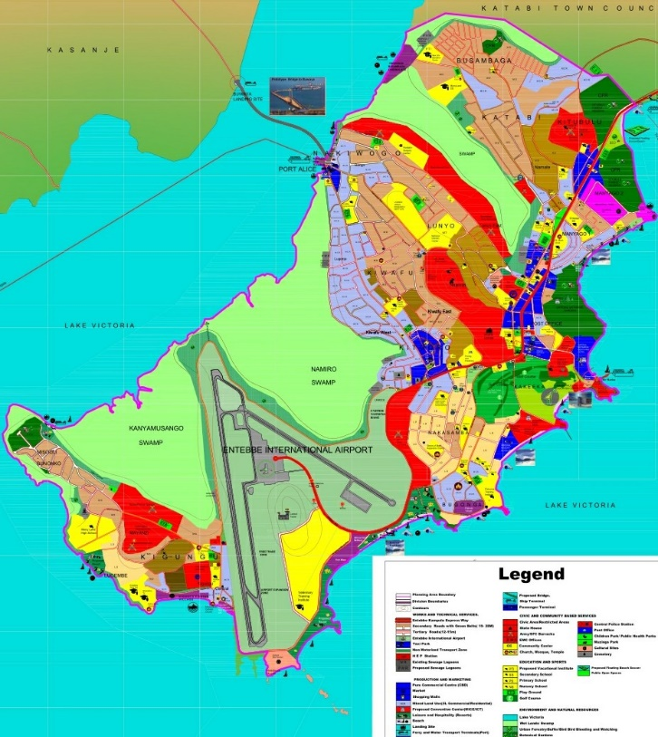

Figure 1 A map of Entebbe Municipality

**2.2 Historical background.**

Entebbe is a Luganda word meaning “a seat “and was probably named that because it was the place where Buganda chief sat to adjudicate legal cases.it fist became a British colonial administrative and commercial Centre in 1893 when sir Gerald portal, a colonial commissioner, used it as a base. Entebbe was most known for the Entebbe state house, Entebbe International airport, Uganda Virus Research Institute, Uganda Wildlife Education Center (UWEC) ZOO and among others.

**Figure 2: Municipal council main building**

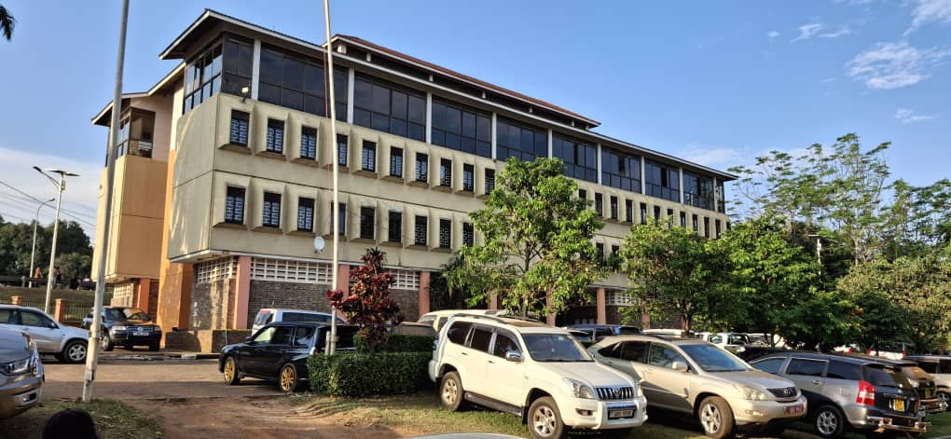

Figure 2 The main building of Entebbe Municipal Council

## **2.3 Mission and Vision.**

### **2.3.1 Mission.**

To ensure coordinated service delivery focusing on national and local priorities in order to improve the quality of life of the people of Entebbe municipality

**2.3.2 Vision.**

Being a model self-sustaining Municipality with a prosperous people by 2040.

## **2.4 Objectives of the organization.**

* To provide democratic and accountable government for local communities.
* To ensure provision of services to community in a sustainable manner
* To promote social and economic development
* To promote safe and healthy environment

# CHAPTER THREE

## **3.0 STRUCTURE OF ENTEBBE MUNICIPAL COUNCIL.**

## **3.1 Planning hierarchy Entebbe Town Council.**

To achieve its mission and vision, Entebbe municipal council has two divisions (A&B) and these comprise of four wards and each ward having a specific number of villages under. EMC administrators therefore carry out their daily tasks in these divisions, implementing planning laws and overseeing the development of each division is collaboration with government and other stakeholders who hold interests in developmental activities.

**Below is the summary of divisions and respective wards in Entebbe Municipal Council.**

|  |  |
| --- | --- |
| **DIVISION A** | **DIVISION B** |
| Katabi ward | Kigungu ward |
| Central ward | Kiwafu ward |

|  |  |  |  |  |
| --- | --- | --- | --- | --- |
| **WARD** | KATABI | CENTRAL | KIGUNGU | KIWAFU |
| **CELL** | Manyago1 | Virus | Bunonko Misoli | Water |
| Water | Lunnyo east | Kigungu central | Kiwafu Central |
| Katabi namate | Bugonga |  | Kiwafu west |
| Manyago 2 | Post office |  |  |
|  | Kitaasi |  |  |
|  | Nakasamba |  |  |
|  | Kakeeka |  |  |
|  | Water |  |  |
|  | Banga Nakiwogo |  |  |
|  | Nsamizi |  |  |

**Figure 3: Approved functional structure for a municipal council**

**Figure 4: Structure of works for a municipal council**

## **3.2 Activities of Entebbe Municipal Council in general**

* Provision of state-run home services and basic unmet needs as regards healthcare, waste management, education, cleanliness, drinking water in homes, recreation and sports.
* Maintaining roads and infrastructure, collecting taxes and revenues, promoting tourism and economic development, ensuring public safety and security as well as coordinating with other government agencies and stakeholders to deliver services to the community.
* The Municipal council set the municipality’s main policy priorities and checks that the municipal executive is implementing them effectively.
* Mobilizing urban community for development purposes.
* The council adopts the budget and checks the municipality’s annual financial report.
* Members of the council all represent local residents, so they must have good links to the community.
* EMC engages in activities that foster the implementation of urban planning and development projects e.g. currently the Entebbe Municipal Physical Development Plan 2020-2040 which is in line with the National Physical Development Plan of Uganda.

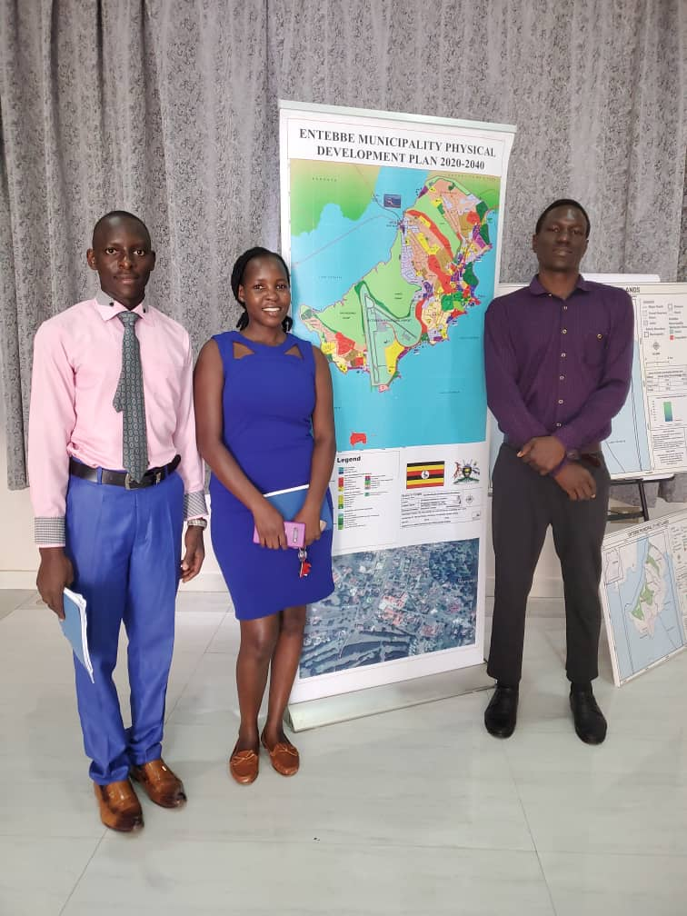

Figure 3 Showing the display of EMC Physical Development Plan 2020-2024

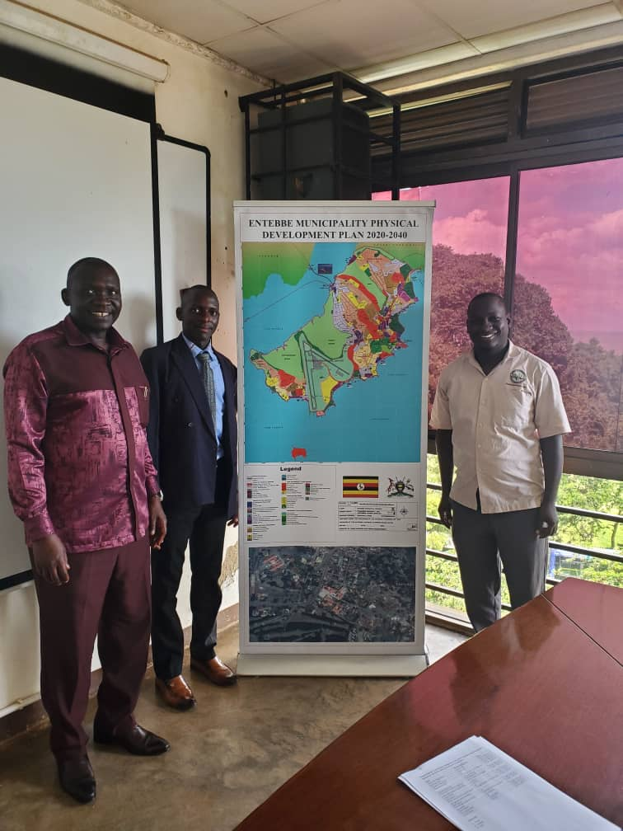

Figure 4 Showing the display of EMC Physical Development Plan

* Council has responsibility to consider all relevant matters brought before it in a proper way, to make informed judgments, decisions and recommendations regarding development of infrastructures, conservation of environment and public health of residents of the municipality.

.

## **3.3 Challenges faced by Entebbe Municipal Council.**

1. Ignorance of the public about planning consent and some people have a negative attitude towards government programs.

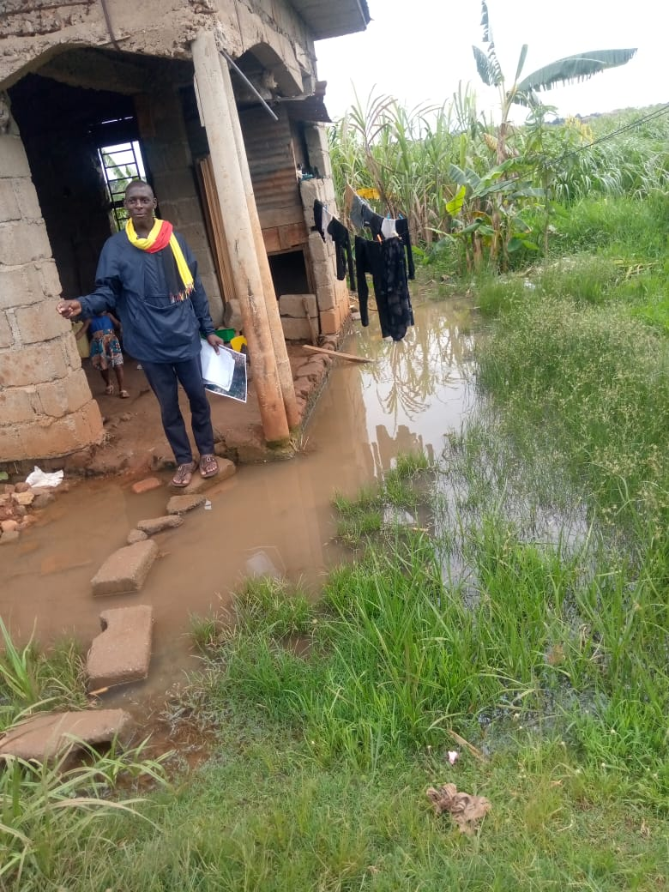

Figure 5 Showing a house which was constructed in a swamp

1. Poor waste disposal/ sanitation. Solid waste management is one of the major problems in the municipal council both in rural and urban areas. Entebbe municipal council is currently creating awareness ecofriendly activities. Section 3 of the national environment act cap 153 prescribes that every person has the right to a healthy environment and subsection 2 prescribes that everyone has mandate to consult local authorities on matters of healthy environment.

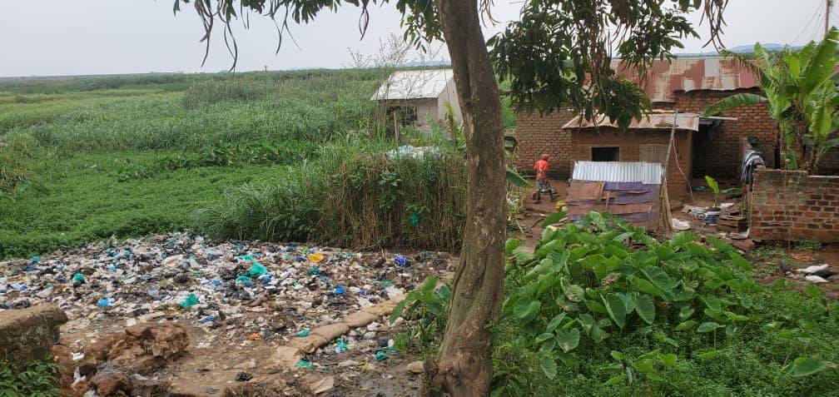

Figure 6 Showing poor solid waste management in Nakiwogo, EMC 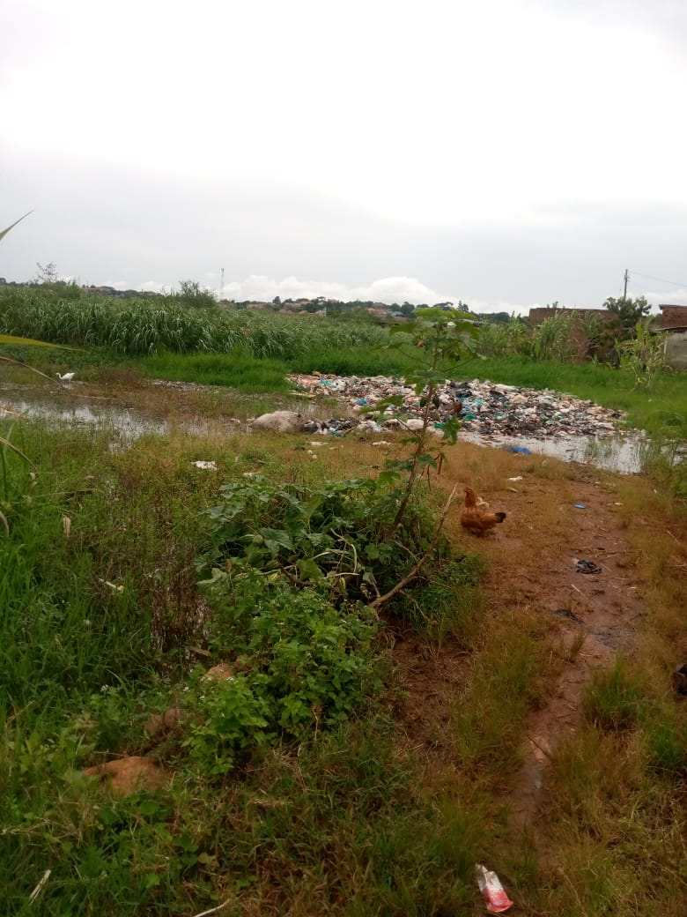

Figure 7 Showing poor solid waste management

1. Limited use of current technologies for example the use of GPS which could have been of a great advantage to the planning committee
2. Breach of the laws that guide development activities by the residents and they are reluctant in paying taxes especially the business community.
3. Insufficient and delay of funds by the Central Government, which are given to the council limits the activities to be carried out in the municipality.
4. Inadequate participation from the community.
5. Encroachments on swamps and wetlands. Entebbe Municipal Council has experienced increased swamp degradation due to desire to set up settlements. Yet laws have been passed in accordance with subsection 3-part a) of the physical planning guidelines that the physical planning committee shall oversee areas with special characteristics such as wetlands, river banks and lake shores.

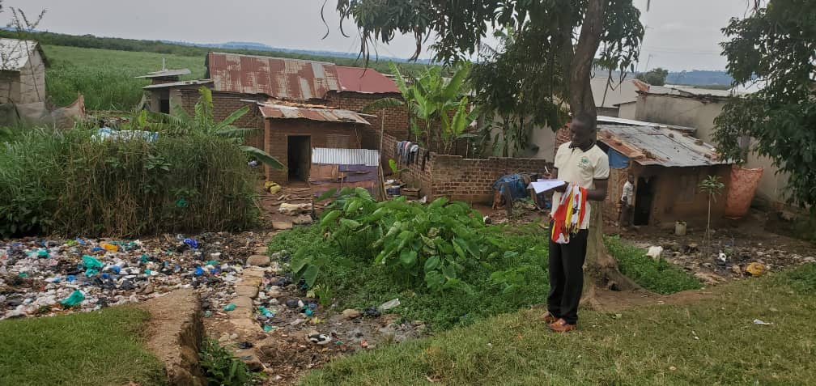

Figure 8 showing the encroachments on a wetland by settlements.

1. The organization lacks sufficient computer reams, scanners and printers to make work faster and easier.
2. Limited revenue base due to limited projects and activities.
3. Land grabbing mainly the government land, church land and school land in Entebbe.
4. The organization lacks sufficient transport means to aid in the movement while carrying out inspections in the council.

## **3.4 possible solutions in order to overcome the challenges of EMC**

* Encouraging participatory planning where residents in the municipality are given opportunity to provide their views or opinions on the plans that best suits their areas to solve the problem of limited public participation.
* The council management should be requested to secure vehicles for the planning committee such that the activities of the department are not delayed
* Provision of more computers and printer to fasten the activities in the planning unit.
* Provision of at least a GPS which can be easily used to locate coordinates to overcome the problem of the limited use of current technologies.
* Sensitizing of the general public about the need to apply for building permits before developing structures such that the problem of ignorance is overcome.

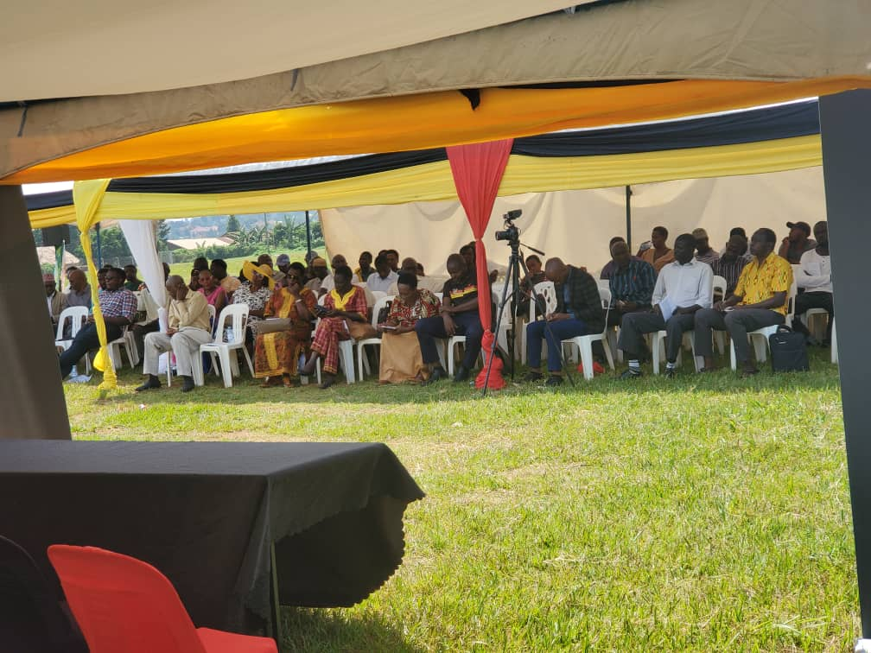

Figure 9 Public sensitization about the National building codes by the National Building Review Board (NBRB)

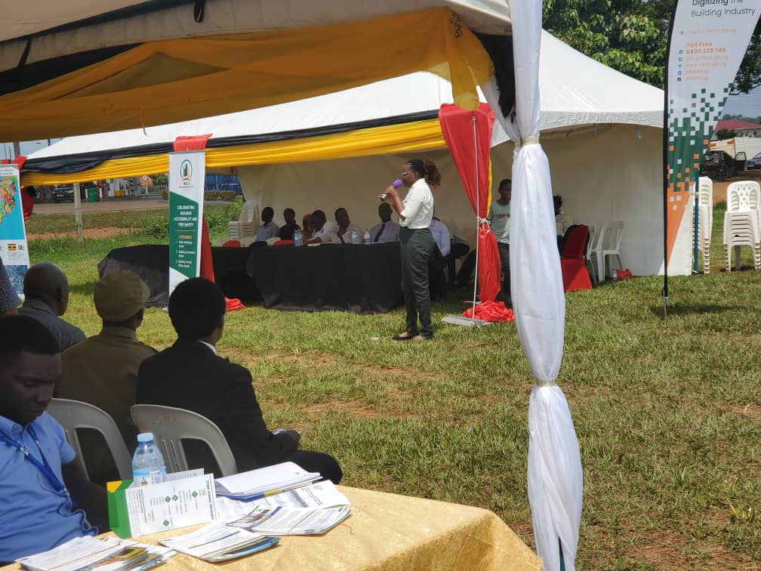

Figure 10 Showing public sensitization by the NBRB incorporation with EMC.

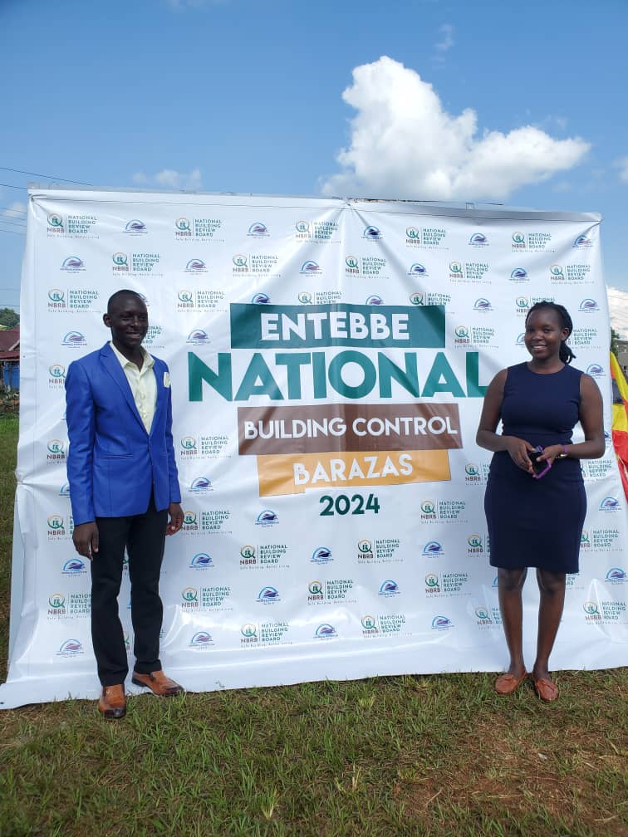

Figure 11 Showing the banner we used at the sensitization

* Widening and improving the revenue base by identification of more sources and building the capacity of the staff in order to solve the challenge of limited revenue base due to limited projects and activities.

# CHAPTER FOUR

## **4.0 THE PHYSICAL PLANNING DEPARTMENT**

## **4.1 Legal Frame Work Guiding Physical Planning Activities at EMC.**

1. **The constitution of the Republic of Uganda.**

This is the supreme law of the republic of Uganda that governs all authorities and people with several provisions that are relevant to physical planning in Uganda.

Ugandan constitution under article237(2)b empowers the local government as determined by the parliament by law, to hold in trust for the people and protect natural physical features i.e. lakes, rivers, wetlands, forest reserves, game reserves, national parks and any land to be reserved for ecological and tourist purposes for the common good of all citizens.

Article 237(7) of the constitution gives parliament the mandate to make laws to enable urban authorities to enforce and implement planning and development.

In regard of the above cited articles, Entebbe Municipal Council Physical Planning Department works together with the community to solve the problems related to land, land uses and preservation of the natural environment.

1. **The Physical Planning Act 2010.**

This is the major act relating to physical planning in Uganda. Section 3 of this act stipulates that “the entire country is declared a planning area and this act shall apply to the entire country in all prospects”.

The physical Planning Act gives the Municipal Council a mandate to plan for its area of jurisdiction since this area is part of the planning area – Uganda.

1. **The National Physical Planning Standards and Guidelines 2011.**

This is a government manual of criteria for determining scale, location and site requirements of various land uses and facilities. The planning standards affect the allocation of scarce land and financial resources.

The Physical Planning department is therefore restricted to carry out its planning activities within EMC in line with the National Physical Planning Guidelines

1. **The Local Government Act 1997.**

This Act defines the structures, powers and functions of local governments. It gives provisions for planning power in the district and lower councils.

Section 31(3) and 36(1,3) of this Act gives urban councils planning autonomy and further defines the planning authority in the district as the district council and how it shall carry out planning in relation to guidelines of the planning authority.

From this Act, the EMC in mandated with responsibility to carry out planning work which includes financial management and overseeing development within the town Council area.

## **4.1 Activities carried out by the Entebbe Municipal Planning Department**

Together with other departments at the Town Council for example the Engineering department, Office of Town clerk, Health and Environment department constitute Physical Planning committee. This committee works hand in hand with the law enforcement team of EMC to carry out the following activities but not limited to;

* Issuing occupation permit, plan assessment and inspection of different sites to assess the feasibility of the buildings so as to obtain then required qualifications.
* Planning for the municipality by monitoring the developmental activities in regard to construction works or utilization of land for the different land uses in the municipality to ensure well planned neighborhood.
* Ensure preservation of natural environment by encouraging developers to conduct present Environmental Impact Assessment reports before plan approvals are done.
* Guiding developers in processing proper building plans, enforcement for building plans and compliance on planning guidelines.
* Approving building plans.
* Demarcating plots in Municipality.
* Drawing the structural land use layout plans and site plans plot (building) developments.

### **4.1.2 Field activities**

This involves going to the field to make observations and take necessary pictures with the aim of providing sound basis for plan approval/disapproval decisions.

* **Site inspection**. It is a requirement by the EMC works department for sites and buildings to be inspected at each and every stage of the construction process.

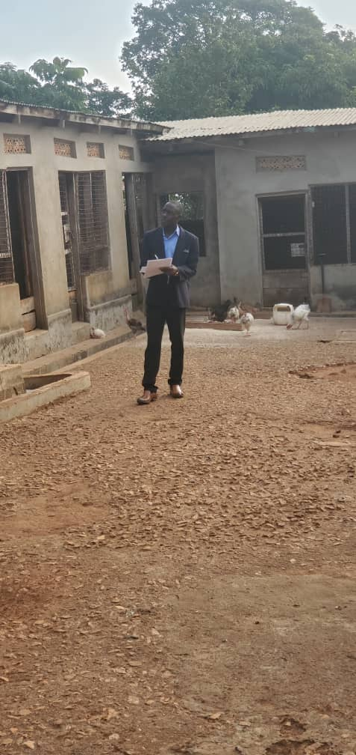

Figure 12 Showing inspection of a plot which needed conversion from customary to freehold

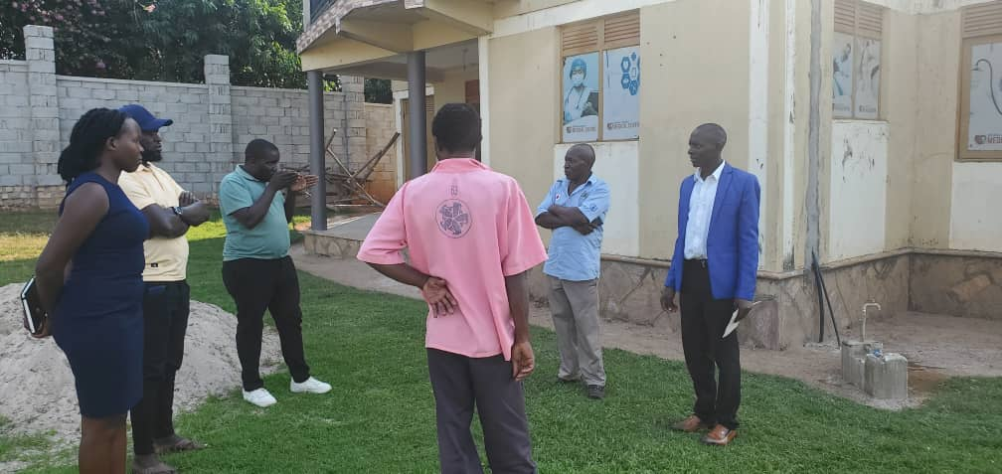

Figure 13 Showing the inspection of a development building

* **Sensitization on physical planning**. The department of physical planning at EMC sensitizes the community on matters concerning physical planning.

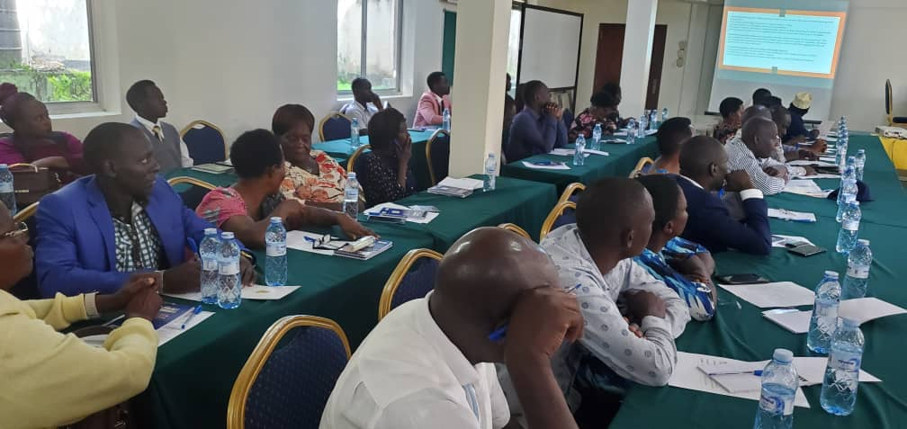

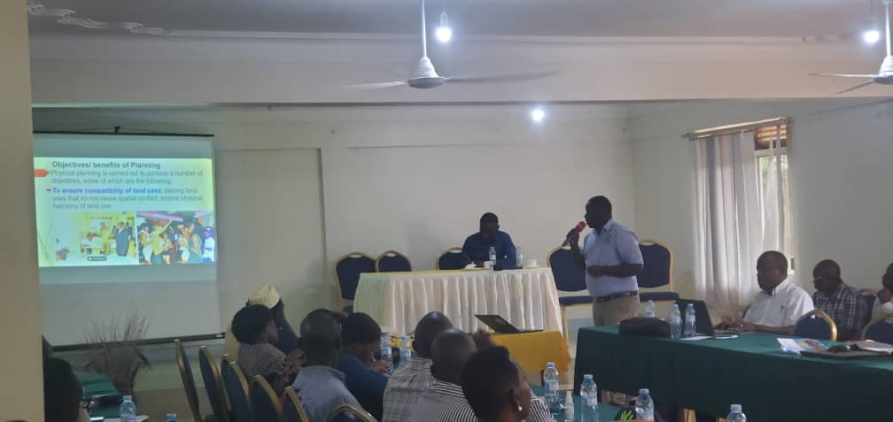Figure 14 A workshop organized to sensitize the leaders of EMC about climate change in Entebbe

Figure 15 Sensitization about physical planning

* illegal building constructions, business that lack trading licenses and buildings that don’t pay property rate.

**SUMMARY OF THE FIELD ACTIVITIES CARRIED OUT**

|  |  |  |
| --- | --- | --- |
| TASK | ACTIVITIES | DELIVERY |
| * Field works | Routine inspection of developments & construction sites.  Survey report verification | Report |
| * Physical development plan (PDP) | Guide public and present the public for proper comments. Participate in sensitization programs. | Reports |

1. **Filling**.

Filling involves the keeping of past and present documents in a safe place that is easy to locate so that even if you are not around someone else in the office should be able to locate the documents. Documents received in the office had to be recorded and filled. The records are stored in box files and plastic files or any available software.

1. **Data entry and analysis.**

This involves use of software for example ArcMap, AutoCAD and QGIS. I had a unique opportunity to learn and practice using these software’s.

iii **Fill forms (PPA forms) to be put in the files.**

These are application forms for either a subdivision of land, new survey of land or consolidation of land directed to the directorate of Physical Planning – KCCA. This form is attached to the information that is put in the file then taken to the PPC at KCCA (city hall) for approval.

What is included; name of the client, the location of the plot, the use for the plot, the organization owning the form plus the directorate to which the form is to be forwarded.

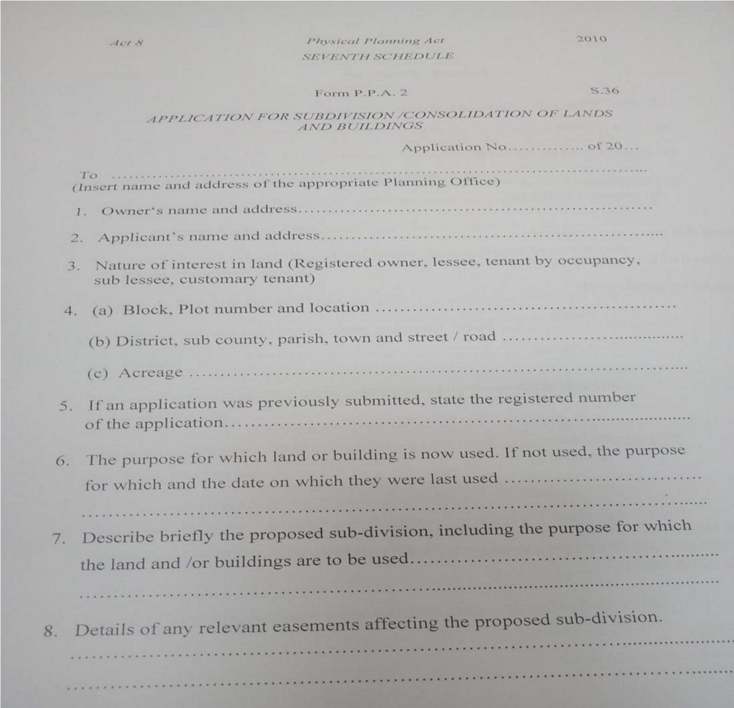

Figure 16 A sample of a PPA 2 form

**iv registering of plans records.**

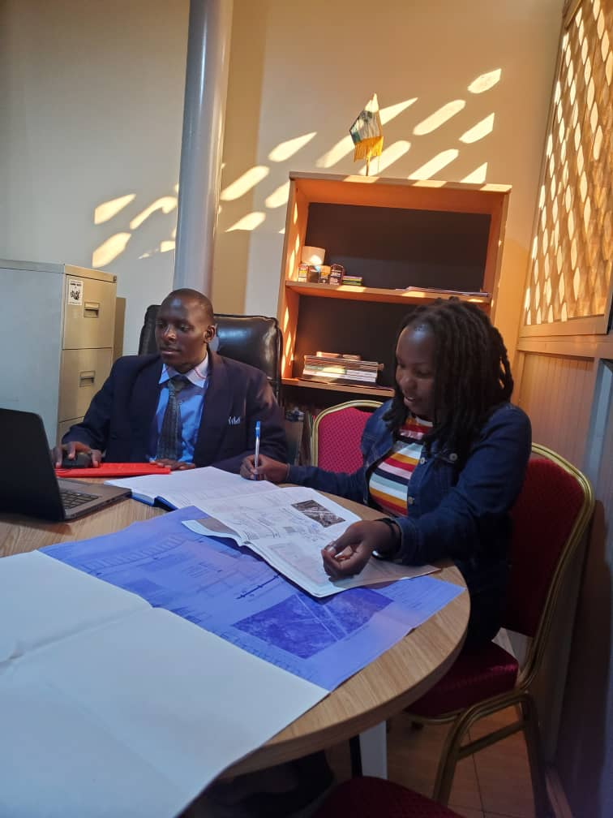This activity involves recording the plan details and entering them in the database for future reference. We were guided by the registry staff who are responsible for keeping these filled plans and other records.

Figure Showing plans recording

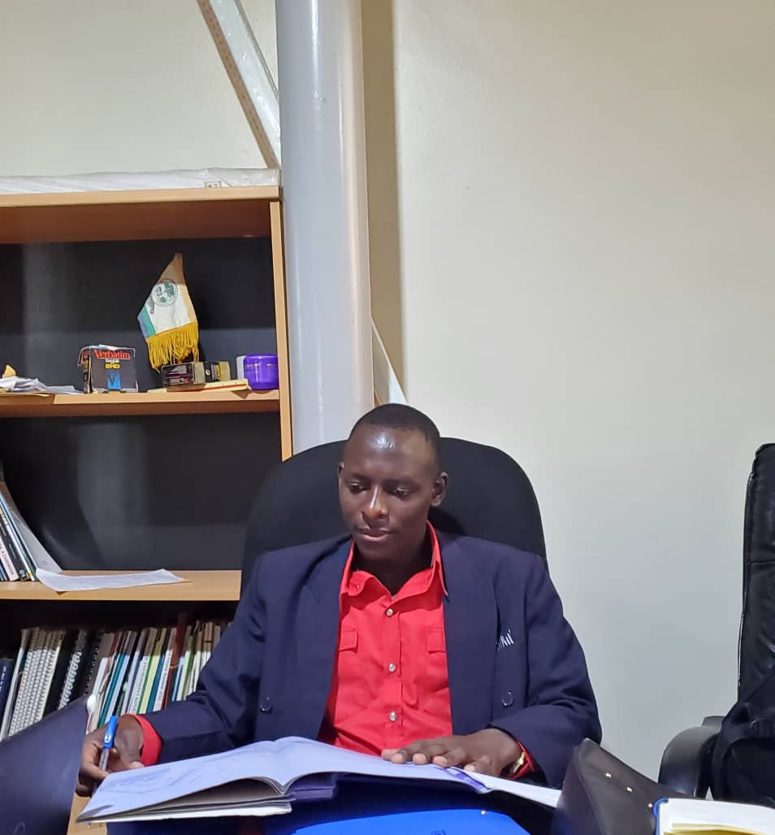

Figure 18 Showing entering of records

**SUMMARY OF THE OFFICE ACTIVITIES CARRIED OUT**

|  |  |  |
| --- | --- | --- |
| ASSIGNMENTS | ACTIVITIES | LESSONS LEARNT |
| * Preparation of the detailed plans and spatial plans for potential areas | Inception meeting with the community that required physical development plan | Presentation  Community approach  Legal frame works  Transformation of theory to practical field. |
| * Attending the PPC committee meetings and other meetings. E.g. consultation meetings with the developers. | * Minute writing and attendance * Presenting the survey reports to the committee * Presenting the received building plans from the developers. * Approving of the plan by relevant committee members such as health inspector, physical planners, town engineer & town clerk the committee chairperson. | Recommending files to the land board and differed files.  Reasons why a file may be differed include;   * If the plot has encroached a surveyed land / plot * If the plot is too big it is recommended for re-planning. * If the plot is too small i.e. not a standard size to the planning of the area. * If the plot doesn’t have a clear access road or has encroached a road. * Meanwhile the check list for building plan approval include the following; * Site plan * Block plan * Ground floor plan * Structure plan (sections) * Elevation * General notes * Checking the ownership of the plot by looking at the tittle, survey reports, and agreement forms etc. |
| Registration of land applications, building plans, and other application files. | Typing and recording | * Report. * Building plan record. * Land application record |

## **4.3 Tasks assigned to the trainee.**

With full instructions from my field supervisor, I was able carryout the following tasks;

* Inspection of developments and construction sites. This was followed by writing a report to the supervisor every after a field visit.

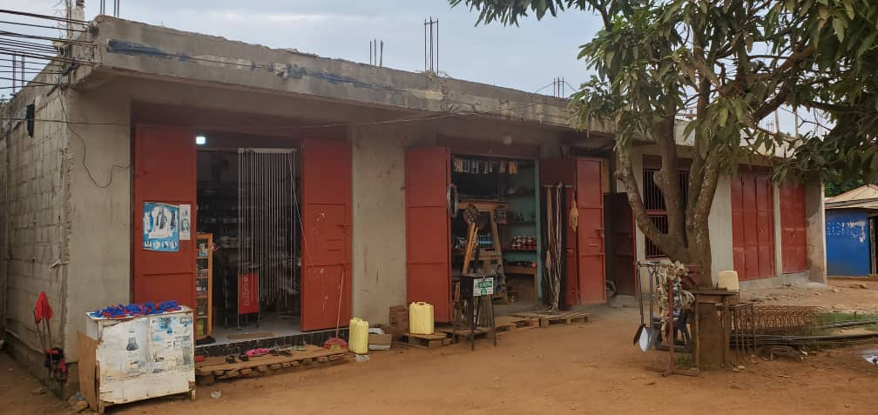

Figure 19 Showing inspection of a commercial building

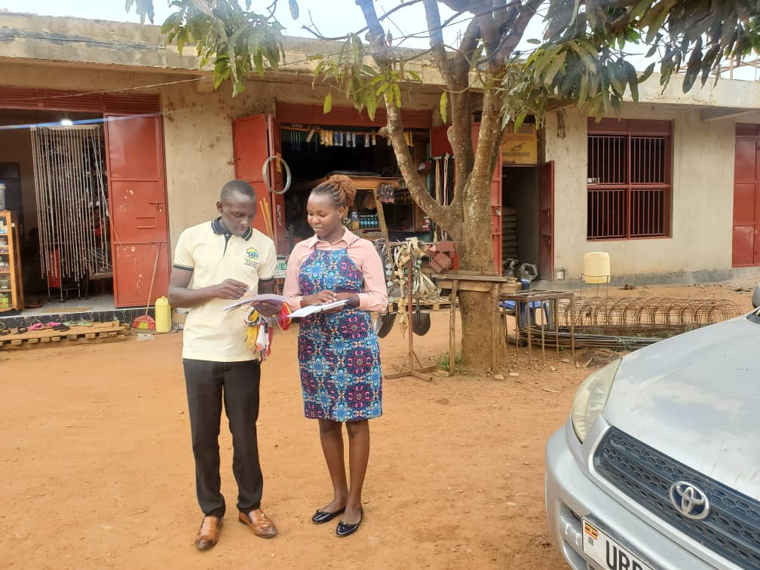

Figure 20 Showing site inspection and filling the requirements on the form

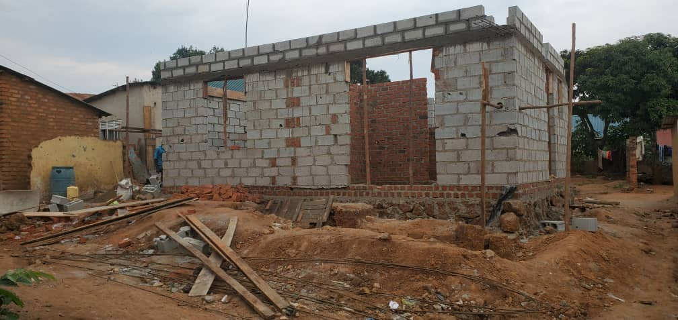

Figure 21 Showing inspection of a residential building

* Sensitization and consultative meetings/ workshops. I was involved in sensitization meetings involving the councilors and chairpersons of EMC e.g. workshop about climate change in Entebbe, a workshop about Environmental conservation in Entebbe and among others.
* Attending to clients, meeting their needs and advising them where necessary about the procedures of carrying out developments in EMC.

**SUMMARY OF TASKS ASSIGNED TO THE TRAINEE.**

|  |  |
| --- | --- |
| **S/N** | **TASK** |
|  | Site inspections and survey inspections. |
|  | Plotting working diagrams by use of survey coordinates. |
|  | Assigned to arrange various records to their corresponding files. |
|  | Picking coordinates using Real Time Kinematic (RTK). |
|  | Typing reports obtained after analyzing the inspection. |
|  | Receive, file and register building plans from clients for proper record keeping purposes. |
|  | Assisting clients in filling Physical Planning application files. |
|  | Properly allocating the parcels of land by use of satellite imagery in QGIS. |

**Equipment’s used through the internship period.**

The following are some of the tools used in obtaining data from both primary and secondary sources;

|  |  |  |
| --- | --- | --- |
| S/N | TOOLS | USE |
|  | Tape measure | Used for taking measurement of distance in the field. |
|  | GPS mobile machine | Picking of coordinates in the field. |
|  | Camera | For taking pictures. |
|  | Desktop computer | Its where software’s like AutoCAD, arc map, arch GIS are installed for carrying out several activities such as, drawing detailed plans. |
|  | Pen and notebook | Used for note taking and recording |

## **4.4 NEW KNOWLEDGE AND SKILLS ACQUIRED FROM THE TRAINING.**

* Technical skills. Most importantly, I was able to attain the technical knowledge such as the analysis of survey reports, considerations before commencement of development which among others include checking the access roads for the case of buildings, checking development permits, constructions should be 30 meters away from the non- encroach-able areas, the use of mobile GPS machines, ArchiCAD.
* Team work skills. I was involved in different works with the different stake holders such as the Municipal Environmental officer, the Land surveyor, the Engineer, and other relevant actors. This made me to understand that team work is the key in order to have best works.
* Communication skills. Due to the interface with different kinds of audiences that I faced in the programs such as sensitization of the public about physical planning, attending different workshops, interaction with politicians and different stake holders made me acquire communication skills.
* I acquired knowledge on the requirements for giving the different consents by the physical planner. These consents include, consent to subdivide, to develop and change of use.
* I attained knowledge on filling PPA forms that show a summary of what is the file for clients and arranging the documents in the file.
* Research and analysis. We did a lot of research and analysis in the preparation of detailed plans and structure plans. For instance, we used a questionnaire approach in collecting data. This helped us in the analysis of existing situation of the areas.
* I also acquired knowledge on inputting the information in the PPC schedule for the plots that meet the requirements for approval.
* I acquired knowledge on scaling, geo-referencing and digitizing a cadaster map in AutoCAD.

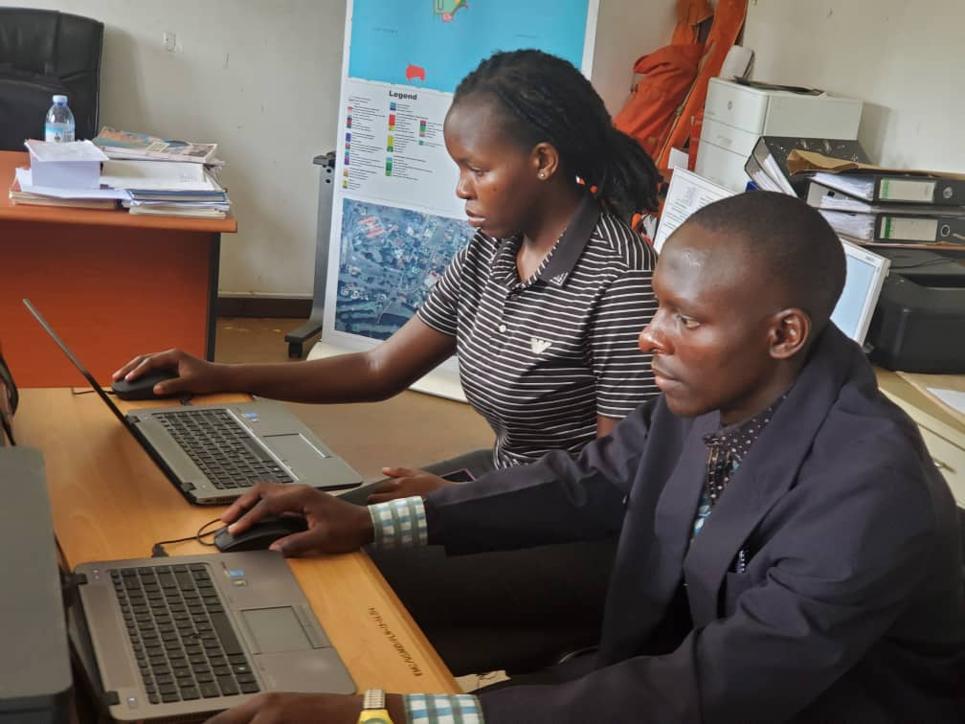

Figure 22 Practicing AutoCAD in the office

* I acquired basic knowledge on coming up with an index diagram showing the area of a plot both in hectares and Acers, the name of the surveyor who carried out the exercise, the location of the plot plus the name of the client, date on which the activity was carried out, the scale used and the access width using survey data collected from the field.
* I learnt how to work and behave uniformly among other seniors at office.

## **4.5 CHALLENGES EXPERIENCED AND HOW THEY WERE HANDLED.**

* Power blackouts in the Municipal council office interrupted works especially those that needed constant power such as computers, printers, Wi-Fi, etc.
* Long distance from home to office, this was solved by preparing early enough to avoid being late for work.
* Limited field works. I handled this by asking questions about what takes place in the field concerning physical planning.

## **4.6 MAJOR BENEFITS ATTAINED FROM THE TRAINING.**

* During the training, I got a vast exposure to different departments.
* Field experience; the training gave me a lot of experience from the field, as it was my first exposer to the working world and facing the different stake holders.
* The industrial training helped me in implementing the theory into practical area of working, this gave me a wider knowledge of understating of the work in particular to my professional.
* I was given a chance by my field supervisor to list down what I wanted to learn during the training which I was taught and attended too positively.
* I got the use of the different word processors specifically, EXCEL, WORD and power point that were commonly used for the production of routine office correspondences and presentations in trainings and workshops.
* Professionalism, the training helped me to attain professionalism as I was given orientation in the first lacked the professional code of conduct, with the mentorship from my supervisor. I understood ethics and professionalism. This helped me to understand how to work professionally.

# CHARPTER FIVE

## **5.0 CONCLUSION AND RECOMMENDATIONS**

## **5.1 CONCLUSION**

In conclusion, I benefited a lot in the field attachment in a way that I managed to apply the theoretical knowledge from the institution into practice through the many activities, tasks and assignments done. The internship improved my skills like interpersonal, listening, presentation skills, acting freely around people, conflict resolution, organizational skills to mention but a few.

I learnt many lessons, which included; how to interpret survey reports, how the working environment runs, site setting and plan interpretation, use of software’s like AutoCAD, ArcGIS, and Arch CAD among others.

I also got different ideas from the different people (employees) at the organization and through interacting with other internees from other institutions like Nkumba University, Makerere University and Kyambogo University, which contributed a lot on the knowledge and experience.

Finally, the internship was fun and therefore I would encourage the management of Entebbe Municipal Council to continue giving students this opportunity to do their academic requirement of internship from their organizations.

## **5.2 RECOMMENDATIONS**

### **5.2.1 To the organization**

1. I recommend that more students at diploma level like me are given a chance to train from the EMC since one gets practical’s skills on how to apply physical planning in the real world, which is a requirement of our institution.
2. The management should buy more facilities such as computers, vehicles so as to enable smooth running of the organization’s activities and respond to the dynamic competition environment. This technological advancement will enable the organization to change from manual to computerized methods of processing documents and proper record keeping.

### **5.2.2 To the institute**

1. I recommend that the academic supervisors should check on the student’s earlier like around the middle of internship period not a few days to the end of the training period. This is convenient for the field supervisors because they may get engaged in other activities towards the end of the period when the academic supervisors do not show up earlier.
2. I recommend the institute to carryout constant supervision and monitoring of students during the internship training to encourage them to perform the duties fully and accurately. This will also put a close link between the academic and the field supervisors to foster appropriate assessment of what the internees are doing in the field.
3. The institute should help students to secure internship positions according to their respective programs undertaken at the institute through giving students recommendations in order to ease their training periods and also avoid the ache gotten by students in search of the internship placements.
4. I also recommend the institute to continue with the internship program, this is because it helps to prepare the students for their careers and also enable them practice the theoretical knowledge obtained during class be exercised practically.

SSEKADDE DALTON SAMUEL

ISLM – ENTEBBE

FRIDAY, 5TH JULY, 2024

TO: THE PHYSICAL PLANNER,

ENTEBBE MUNICIPAL COUNCIL

DEAR MADAM;

RE: **A REPORT ON SITE INSPECTION OF ESTABLISHMENT OF SIGNPOSTS OF ENTEBBE CHRISTIAN CHURCH AND SCHOOL ON NSAMIZI ROAD AND LUNYO ROAD.**

TERMS OF REFERENCE:

From the site inspection which was carried out on Friday,5th July 2024 along Nsamizi and Lunyo roads, I was instructed by the physical planner to write a report and present the findings, recommendations and conclusion.

FINDINGS:

* Visibility; visibility was good along most sections of the road, with some areas obstructed by the already existing signposts.

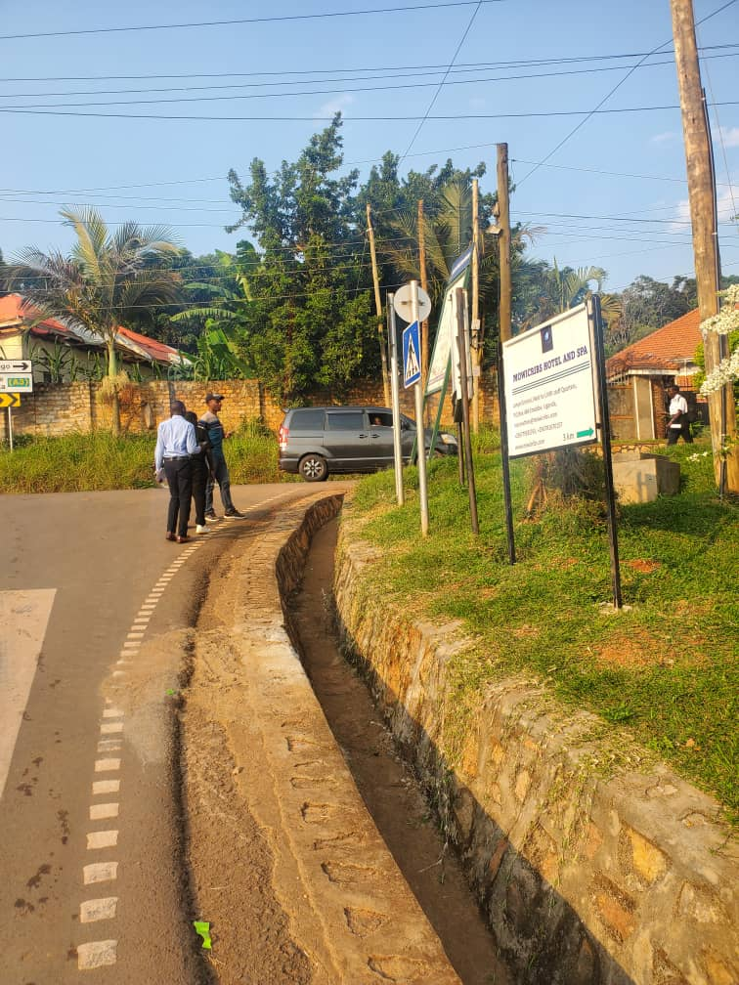

*Figure 1: showing the obstruction by already existing signpost.*

* Pedestrian and Cyclist activity; Pedestrian and cyclist activity was observed at various points along the road.

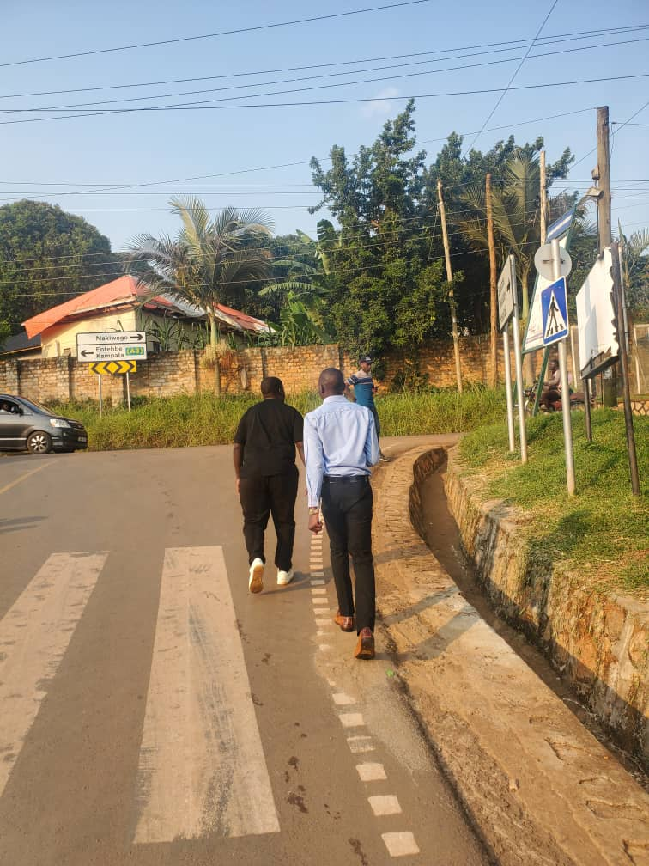

*Figure 2: showing the pedestrian and cyclist activity*

PROPOSED SIGN POST LOCATIONS/ COORDINATES:

* Location 1; Point 1 is along Nsamizi road on coordinates 69225N, 441129E

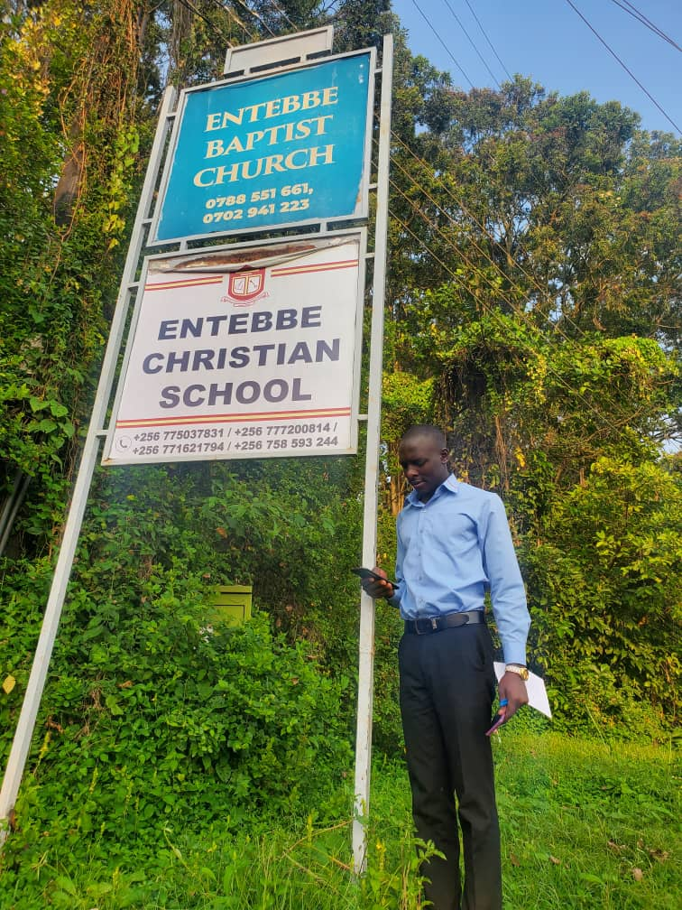

* Location 2; Point 2 is along Lunyo road NMS junction on coordinates 7024N, 441012E.

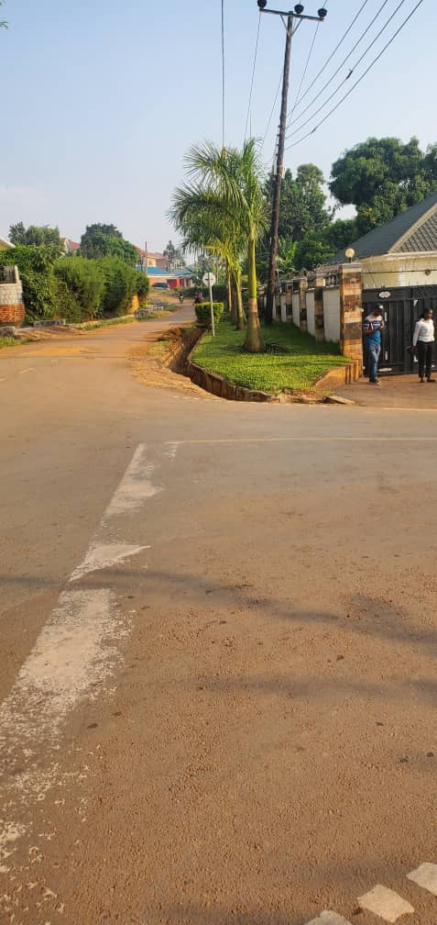

*Figure 3: showing the proposed location of signpost 2*

* Location 3; Point 3 is along Lunyo road on coordinates 7302N, 440818E.

Figure 4: showing the proposed location of signpost 3

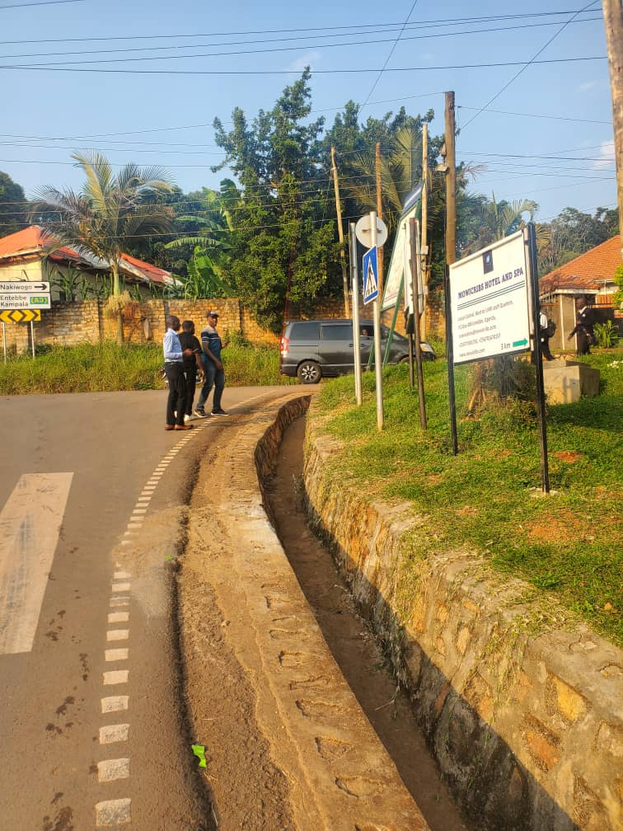

* Location 4; Point 4 is along Masiro road, Lunyo plot 25-29, East Division A Entebbe Municipal Council on the entrance of the school.

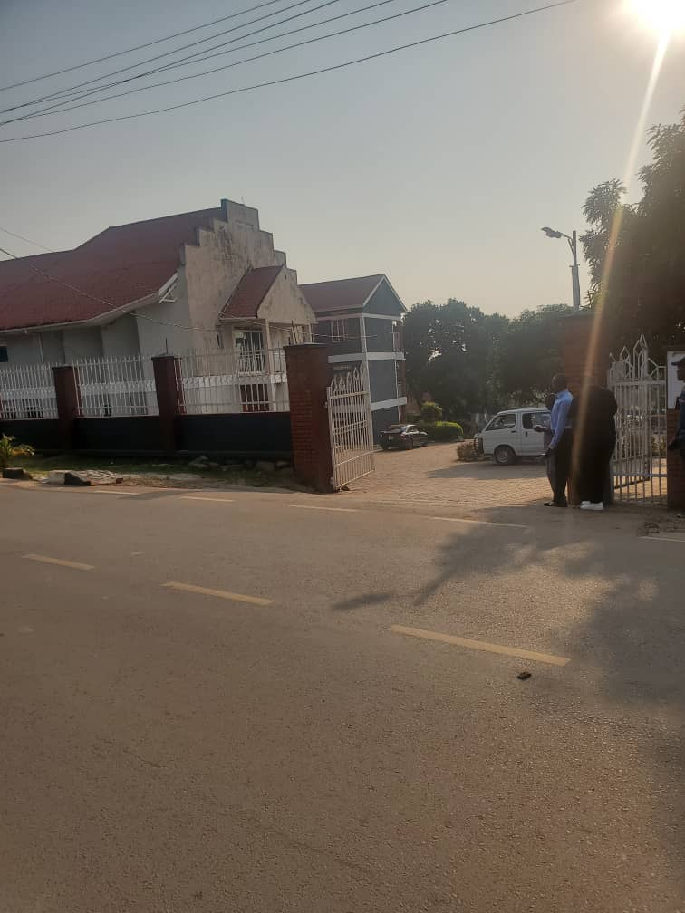

CONCLUSION:

The site inspection revealed suitable locations for sign posts along roads, enhancing road safety and navigation.

RECOMMENDATIONS:

I recommend the installation of signposts at the proposed locations to enhance road safety and navigation.

I recommend the use of solar-powered or reflective signposts to enhance visibility and sustainability

…………………………………………………

SSEKADDE DALTON SAMUEL

INTERNSHIP STUDENT- PHYSICAL PLANNING UNIT.

SSEKADDE DALTON SAMUEL

ISLM – ENTEBBE

TUESDAY, JULY 2, 2024

TO: THE PHYSICAL PLANNER,

ENTEBBE MUNICIPAL COUNCIL

DEAR MADAM;

RE: **A REPORT ON SITE INSPECTION OF A DEVELOPMENT IN KIGUNGU CENTRAL, DIVISION B ENTEBBE MUNICIPAL COUNCIL.**

TERMS OF REFERENCE:

From the site inspection which was carried out on Monday,1st July 2024 in Kigungu, I was instructed by the physical planner to write a report and present the findings, recommendations and conclusion.

FINDINGS:

* Land use: The building is located in a residential area with the designated zoning regulations.
* Setbacks; The building’s setbacks (2m) from the property lines are consistent with the required standards.

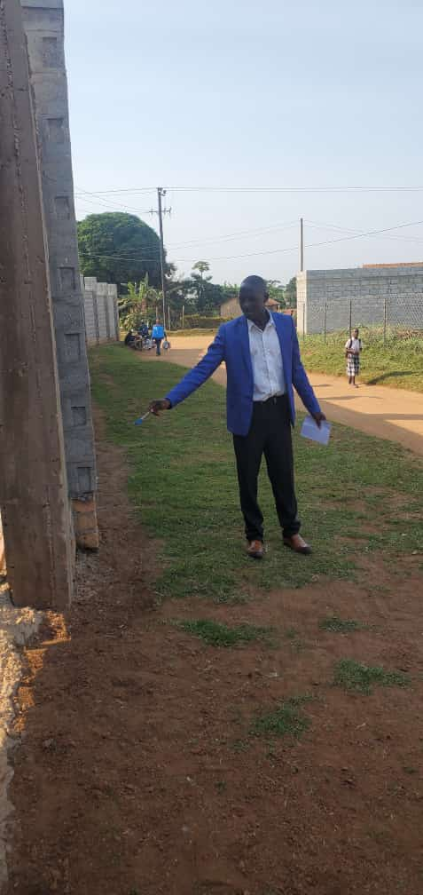

Figure 1: showing a setback

* 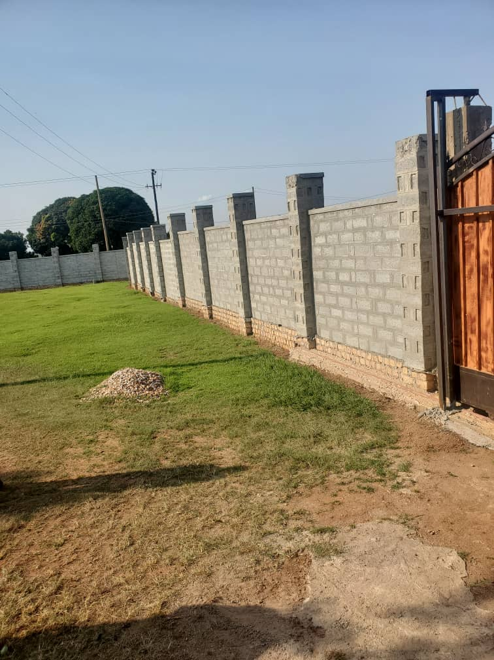Parking; The building has an ample parking space and therefore the parking provisions meets the necessary requirements.

Figure 2: showing the ample space for parking and green grass

* Accessibility; The Building is accessible by a road of about (6m) and therefore the access points for both pedestrian and vehicles are generally satisfactory.

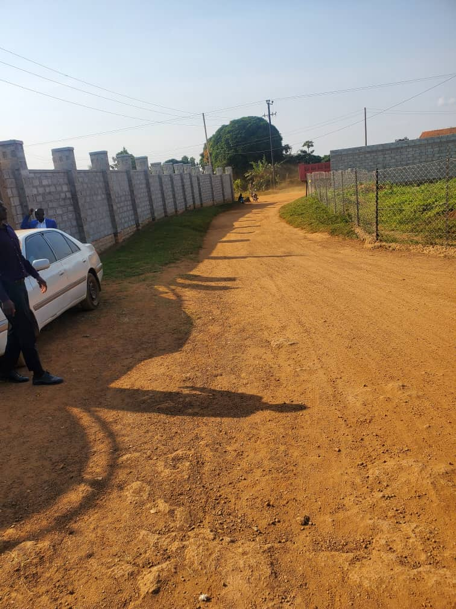

Figure 3: Showing the accessible road of the building

* Building Height and Floor Area Ratio (FAR); The building height and floor area ratio are within the allowed limits only the fence which is so high and it may need to be improved.

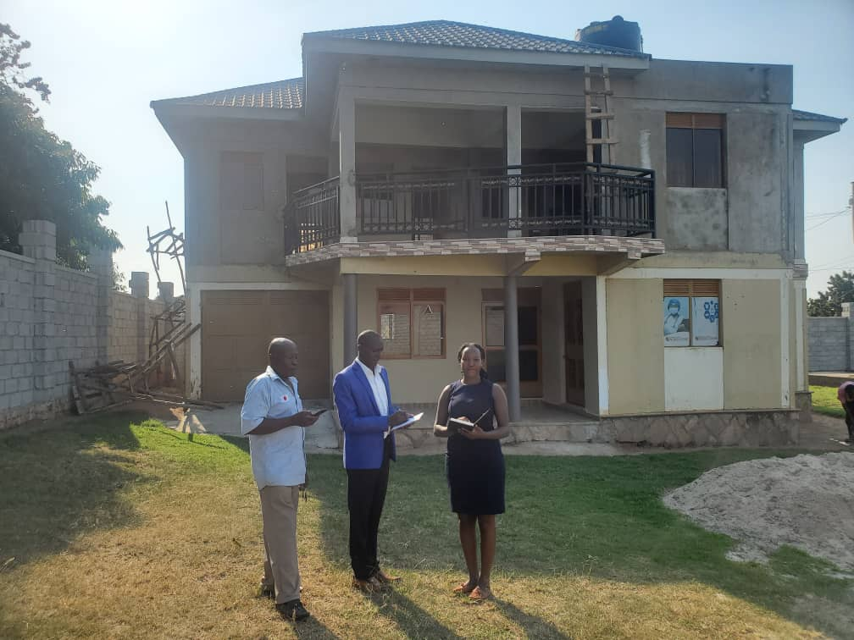

Figure 4: Showing the Building Height and Floor Area Ratio

* Drainage; drainage is by natural percolation due to grass planted in the compound.

CONCLUSION:

The constructed building generally complies with physical planning regulations and standards. However, some minor adjustments and improvements are recommended to enhance its functionality, accessibility and aesthetic appeal.

RECOMMENDATIONS:

I recommend the contractor to reduce on the height of the fence wall.

I recommend the client to consider additional aesthetic features e.g. planting some trees in the compound to enhance the building’s visual appeal.

…………………………………………………

SSEKADDE DALTON SAMUEL

INTERNSHIP STUDENT- PHYSICAL PLANNING.

# REFERENCES

1. [www.entebbe.go.ug.](http://www.entebbe.go.ug.)
2. Internet
3. Lecturer’s notes
4. The Physical Planning Act 2010 as Amended
5. The constitution of the Republic of Uganda 1995.
6. Physical Planning Guidelines 2011.

# 5.3 APPENDICES

## **APPENDIX A: INTERNISHIP LOGBOOK.**

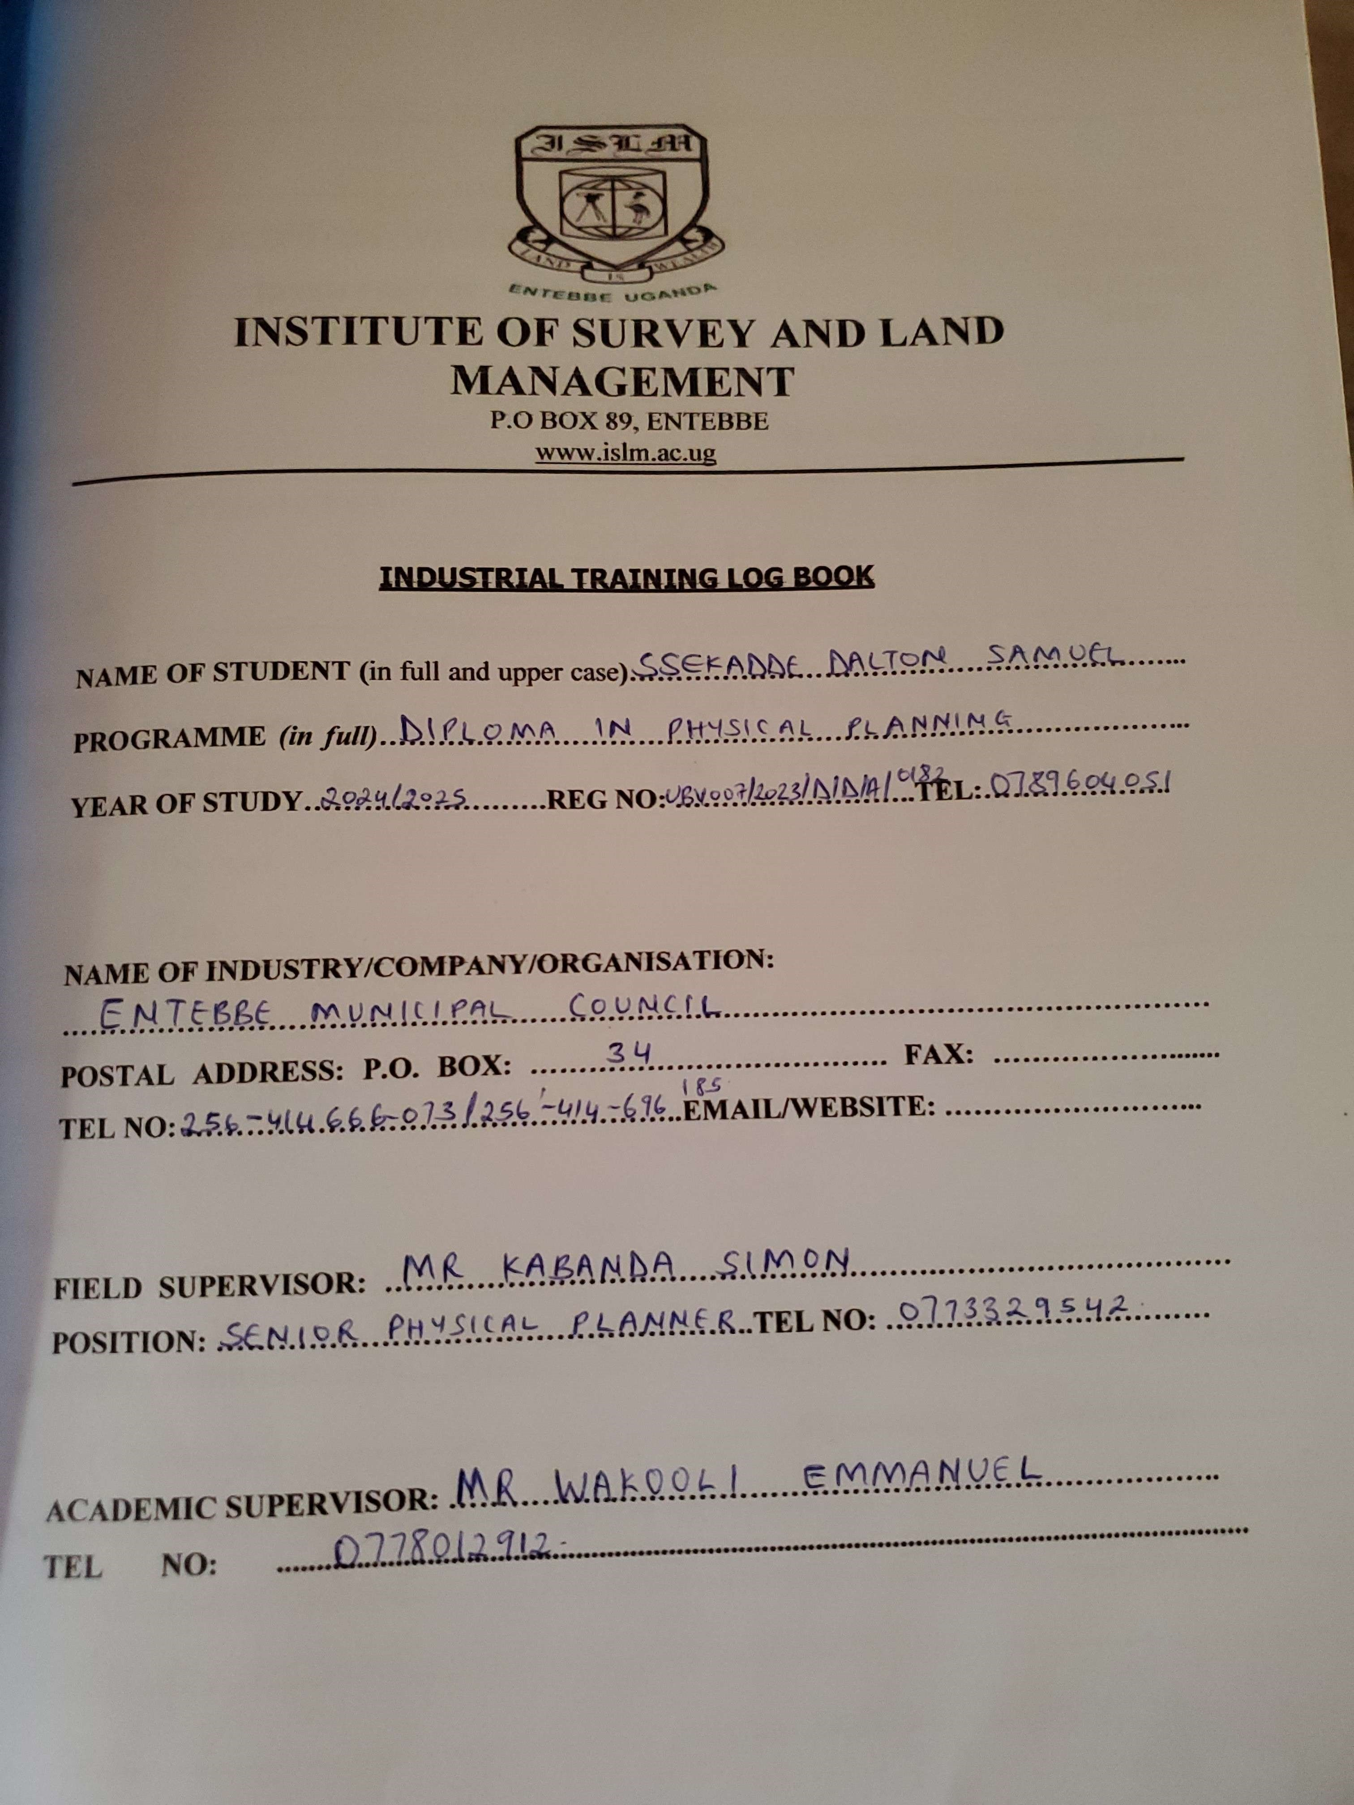

## **APPENDIX B: REQUIREMENTS FOR DEVELOPMENT PERMISSION.**

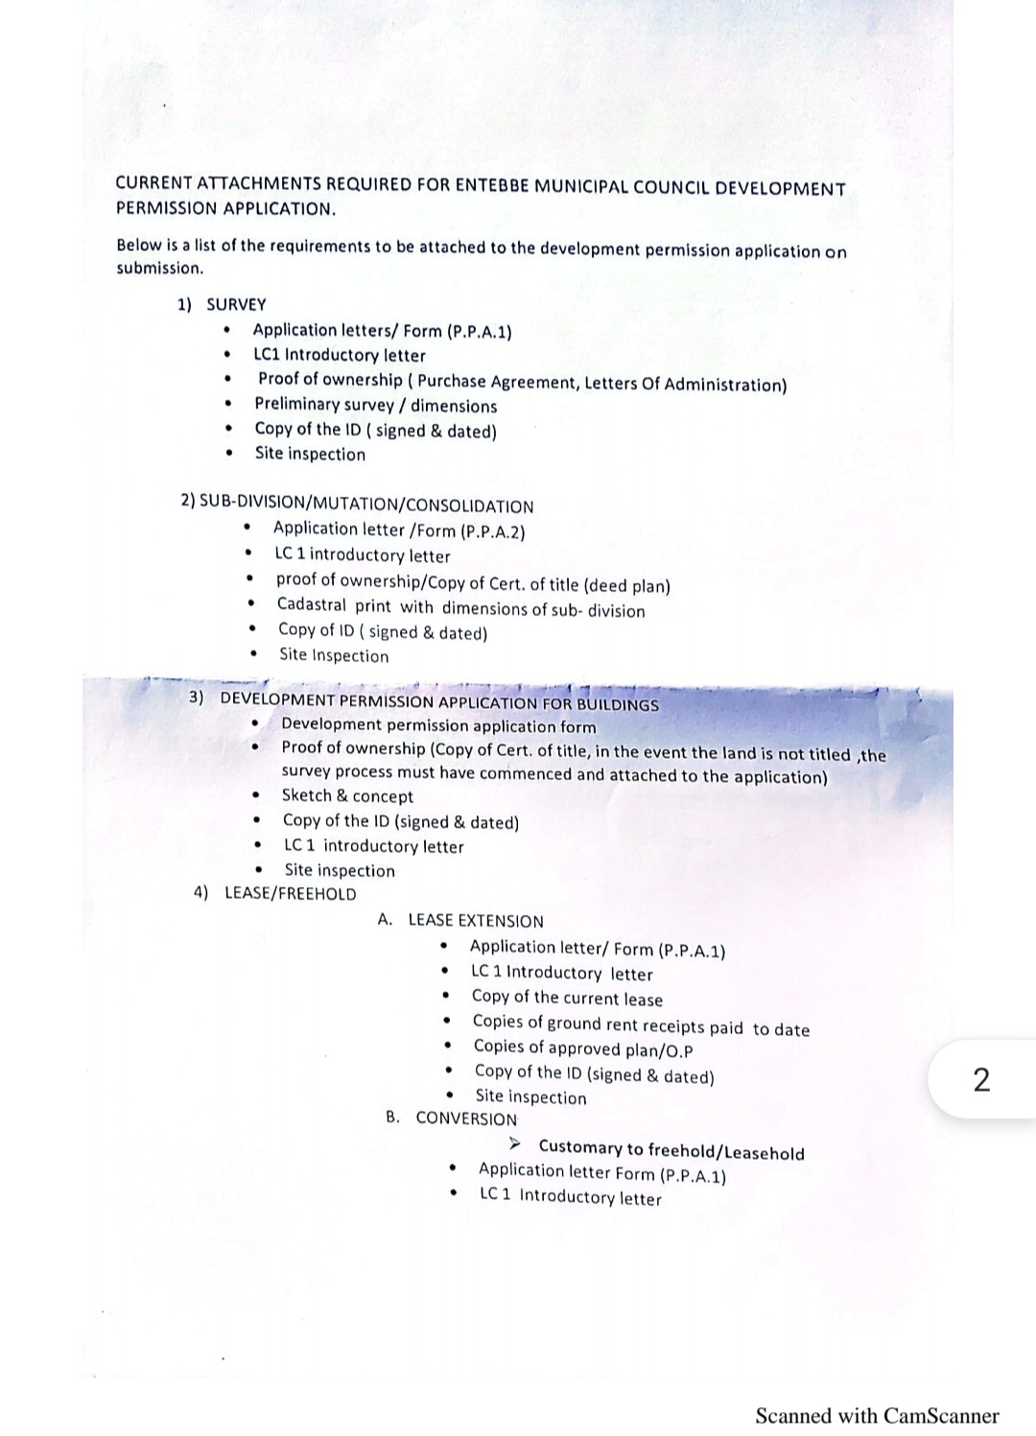

## **APPENDIX C: SITE INSPECTION REPORT.**

